For Immediate Release:
Angelle Barbazon, publicist
JKS Communications
angelle@jkscommunciations.com
(615) 928- 2462

Infamous Las Vegas Madam emerging from shadows with new book
Jami Rodman gives a racy glimpse between the sheets of
high-priced call girls in Sin City

LAS VEGAS – Step into seductive world of Jami Rodman, a woman known as the Las Vegas Madam. There’s glitz. There’s glamour. There’s sex…and lots of it.

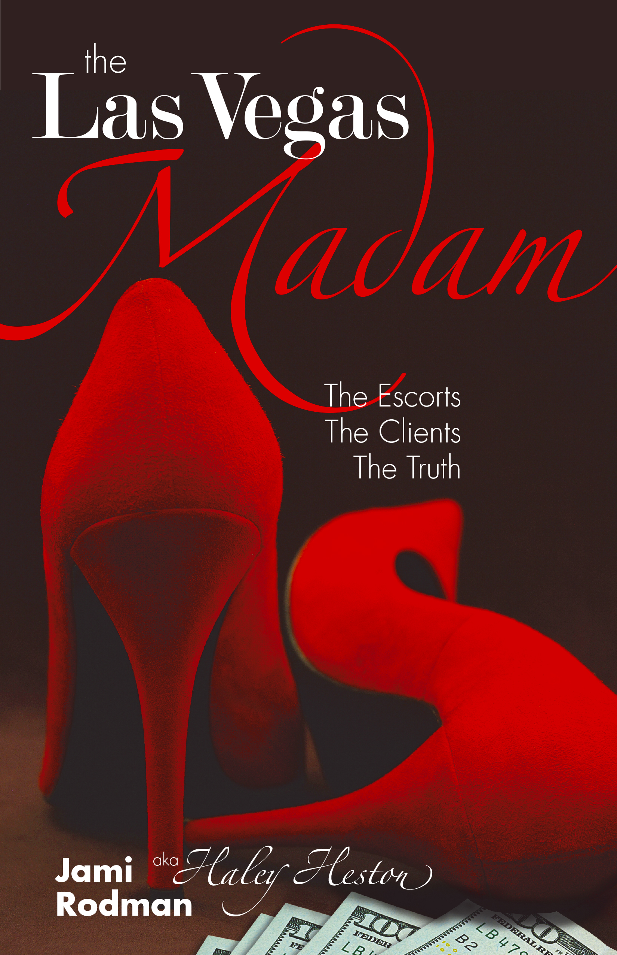
For the first time, Rodman is undressing Sin City’s underground sex industry with The Las Vegas Madam: The Escorts, The Clients, The Truth (December 11, 2015). A salacious read that reaches into the depths of emotional extremes, Rodman’s new memoir gives a shockingly honest and and unforgettable peek inside a world that few rarely see.

Yearning to break away from her smalltown Christian upbringing in Oregon, Rodman did as any sprouting young invincible woman would do – she escaped to Las Vegas. Known for hiring Olympic athlete Suzy Favor-Hamilton to her team of high-priced call girls, Rodman spent 10 years building one of the most elite escort agencies in Vegas. Fighting pimps and disgruntled boyfriends, her biggest contender happened to be battling her own past.

Rodman offers a unique, essentially sociological, perspective that does not often find its way into the spotlight. She has emerged, after a decade of cultural immersion, to share her experience, education and insight on a trending social movement.

The Las Vegas Madam is glittery, fast paced and damn sexy. Mixing a quintessential cocktail of erotic pleasure, money and hot women, meet the secret society of high-end escorts and the men who hire them for companionship.

Jami Rodman is a writer with an unabashed approach to sexuality and relationships. She has a background in cultural anthropology and sociology, but her stories really come alive when she recounts her last decade of adventures, first as an elite escort and then as the high-powered Las Vegas Madam.

About the Book
THE LAS VEGAS MADAM:
THE ESCORTS, THE CLIENTS, THE TRUTH

The Las Vegas Madam: The Escorts, the Clients, the Truth takes you inside the life of a call girl as she spirals into a world of glamour and secrets. When a scandalous news story splashed across mainstream media about an elite escort agency in Las Vegas, people were shocked to learn there was a tiny mastermind behind the company – a small town girl from Oregon named Jami Rodman went by the pseudonym “Haley Heston.” Meet the secret society of high-end escorts and the men who hire them. Rodman unveils the highly lucrative business of sex, the hidden websites and layers of complex networking to satisfy man’s endless desire for sex.

Timed with the 2007 collapse, Vegas cultivated a new, unprecedented class of call girls – ones with brains, beauty and savvy. Together with Rodman’s agency, they cleaned up the soiled reputation of prostitution in Las Vegas. Weathering competition from desperate, violent, and successful pimps and madams, hosting swanky parties, and serving clients in cities that spanned the globe, her agency ruled the oldest profession, for a while.

The Las Vegas Madam is a provocative memoir of one girl’s journey into prostitution and how quickly a fast-paced life built a wedge between her and the very thing she was seeking to begin with – love, friendship and meaning. She replaces loneliness with companionship, both as a hired prostitute and recreationally. In a desperate attempt to bond with others, to be liked, fit in, to escape an oppressive religion, and push the crushing void of emptiness aside, she tries to fill it with sex, drugs, relationships, money and power.

As she rose from a popular call girl into a powerful madam, Rodman discovered most people she met in the sex industry were there for similar reasons – loneliness, isolation from the world around them, and to fill needs that weren’t met elsewhere. She realized she was traveling down a similar path as her clients, and decides to make changes. Inside was a new stronger self who made friends with the old. There were opportunities to find meaning, and provide the same to those around her. It was when she brought those two people together that she learns to love again, have compassion for her clients and herself, and understand what brought her there to begin with.

An Interview with
JAMI RODMAN

How did you get involved in escorting?
To my friends and I, escorting was more logical, and often safer, than the dating scene. We were young and living in a city where one night stands were the norm following a long night of clubbing. Online dating, like Match.com, or otherwise nicknamed Snatch.com, didn’t fare any better. Peeping Toms and stalkers came from both routes. Beautiful people selling sex was seemingly everywhere, on billboards, in magazines, ads for nightclubs and restaurants, and the more provocative one was, the better she did financially. So when the tipping point presented itself – I was cocktail waitressing and dancing at a strip club, plus flat broke with bills to pay – I took it.

Why did you start an escort agency?
To be honest, I started an agency at the suggestion of client I was dating at the time. It seemed like a good idea. All of us in Vegas, felt the economic downturn pretty hard. I had a lot of friends from my previous escort days, and they were all looking for a way to increase business. I could use the added income while my other business got off the ground. Over the course of a weekend, I started building a website, and a few months later, there we were.

What was the hardest part of running an agency?
I never expected to become as personally involved with all the women. When they had problems at home, with their families and children, I was there to listen and to help. I was their sounding board. Then, when I started seeing a different side to prostitution – specifically the pimps and how they handle their business – it was even more difficult to watch how it affected my friends. But first of all, I had to get the agency off the ground. Las Vegas had a bad reputation for rip-off agencies and escorts. To clean up the industry and break into the market took a lot of dedication, time, and perseverance, just like any business.

Did you work with any famous people?
A true professional never tells!

In the book you use the terms escort, prostitute, call girl, courtesan, sugar baby concurrently. Do you make a clear distinction between them?
I apply these labels loosely. Although they may come with different rates and expectations – a hooker might spread her legs for a quickie in the back seat of a car. Or an escort puts in more time, invests in lingerie to take it off with notes of a song. Maybe a courtesan does all the above, but adds in conversation over a glass of wine to mimic the act of a long lost girlfriend. However, at the end of the day, when it’s all said and done, we all played all roles. We saw the same guys. We went through similar internal struggles. Our buyers – Johns, clients, customers, tricks and sugar daddies – were equally alike. Most importantly, we all faced deep life-changes because of the choices we made to identify ourselves with those labels.

Who would buy your book?
Any woman who wants to know what her husband really wants in the bedroom. Any man who wants to know what an escort is really thinking when they’re together.

What do your family and friends think you do?
It’s all out on the table now! During my time as an escort and a madam, I did things “normal” people do. I went to school. I worked. I started a company. I didn’t give up my whole life to become an escort and a madam. To me, being an escort was a chance to explore, an accessory to my life. It was fun times remembered with a smile. Being an escort is a myriad of emotions, a constant shift of excitement, enjoyment, disgust, boredom and loneliness. Escorts are lonely. We socialize constantly.

What was the hardest part of escorting?
Honestly, for me, the hardest part of escorting was not escorting itself. It was guilt and loneliness, not for being an escort, but for my prosperity, the inequality of who I had become when I flaunted my wealth alongside wealthy clients. I’d rather sit in coach with “normal people” than plop down in first class, demanding my drinks have the right amount of ice cubes, avoiding eye contact with those around me, and pretending to be someone I’m not. I also didn’t like seeing how lonely some of my clients were and charging them for the service of being their friend and hanging out.

What did you enjoy most?
I met a lot of amazing and fascinating people. I traveled to places I never would have otherwise. I was able to explore my sexual curiosities in a positive and safe manner.

Do you regret what you have done?
I do not regret who I am. I’ve had the opportunity to empower women, and men, and change their lives in ways I never could have without being an escort and a madam. I’ve saved marriages, freed girls from pimps and traveled around the world doing humanitarian work. I don’t see any reason to be ashamed of that.

What are some misconceptions about escorts?
The number one misconception about escorts is that we are just hired for sex. There’s so much involved in being a paid companion. We’re educated and knowledgeable on current events, we plan our dates with precision, take the utmost care in our presentation, dress appropriately, and it is true, we do love sex (the good ones anyway)!

After reading this book and walking in the shoes of an escort, some people might call you a home wrecker, what do you say about that?
I would say exactly the opposite! Men who look for female attention, outside their wife or girlfriend, are going to regardless if I’m around or someone else. I would say it’s better that he hire an escort than find a girlfriend or mistress on the side. With an escort, at least intentions are clear.

You’re not model gorgeous or strikingly beautiful. You’re of average height, and have things like birthmarks and scars – you make that clear in your book. Why would a guy pay $5,000 a night to hang out with you then?
(My boyfriend thinks I’m strikingly beautiful and that’s what counts!) Guys want to feel comfortable, adored and paid attention to. Most would rather open the door to a pretty girl next door who he’s going to be able to talk with over drinks. Someone who will make him laugh, and laugh back. They don’t want a Barbie, and those that do, know where to find her.

Are you still friends with any of the clients or women you met during the industry?
Absolutely! I made some life-long friends, incredible women and men, who I likely wouldn’t have ever met if I had not had the opportunities I did.

Are there any last words you want to add?
I’ve heard the questions above time and again, and perfected short, simple answers to all of them. But summing up my entire life in a few sentences could never do it justice. That’s why I wrote this book. It’s all out on the table – my whole life, history, feelings and thoughts – some are embarrassing and painful, but they’re the truth. I did it in so those reading will take something from it. Whether it’s a simple curiosity that has been answered, or deep questions long overdue.

THE LAS VEGAS MADAM: THE ESCORTS, THE CLIENTS, THE TRUTH
By Jami Rodman • Releasing December 11, 2015
ISBN: 978-0-9965682-0-3 (paperback) • 978-0-9965682-1-0 (ebook)
$19.99 (paperback) • $9.99 (ebook)
Memoir, Erotica, 18+    

